Before filling out, please refer to the Lamont-Doherty Core Repository [Sample Request Guidelines](http://www.ldeo.columbia.edu/core-repository/samples-services/sample-request-guidelines). Follow instructions carefully -- requests cannot be processed unless information is complete. Please email to the [Curator](mailto:peridote@ldeo.columbia.edu) when complete.

**Date:**   
  
**1. Name, affiliation & address:**

**Phone/e-mail:**

**2. List name(s), affiliation, and email address of collaborating investigators:**

**3. Samples for (check one):**

Research:   
 Teaching:   
 Display:   
 Other:   
  
**4. Project Title:**

**5. New request or subsequent/continuation-of-project?**

**6. Supported by (check one or more; give approximate proportions [in %] if two or more -- give NO monetary amounts):**   
  
 NSF:                USGS:   
 ONR:                NASA:   
 DOE:                Other:   
  
**7. If the work will be part of a larger program, please identify:**

**8. Brief description (paragraph) of project covering each of the points below.**   
 1)  objective:   
 2)  specific geographic area:   
 3)  role of collaborating investigators:   
 4)  methods and procedures:   
 5)  brief  justification for additional samples (if needed):

**9. Samples needed (please refer to section** [**Sample Request Guidelines**](http://www.ldeo.columbia.edu/core-repository/samples-services/sample-request-guidelines)**) :**

(Double click within the table to open an Excel worksheet.)

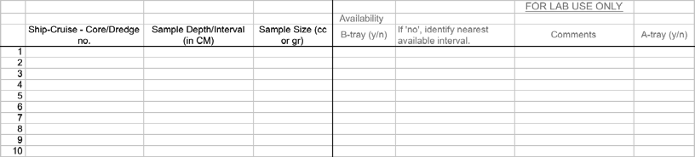

**10. Please note any special sampling, handling, packing, mailing, etc.**

**11. Whenever feasible return unused samples or sample residues.  If this is not possible please explain why.**

**12. Will you be here to do the sampling?**

Yes:   
 No:   
 Maybe (explain):

Acceptance of and publishing on research related to samples/data distributed by this repository involve distinct responsibilities on the part of the requester -- these are defined in the Lamont-Doherty Core Repository [Sample Request Guidelines](http://www.ldeo.columbia.edu/core-repository/samples-services/sample-request-guidelines).